10 Things You Can Do to Care for Your Digital Video Works

1. When you make a budget for your project, include a hard drive to store of your finished work and all of the important files associated with it.

2. Before you start shooting, choose a naming convention for all your tapes. Each tape will have a unique number but will start with the same prefix. For example, if your working title is “Art of Resistance”, you could use a naming convention of AR plus a three digit number, for example, AR001, AR002, etc. The number must be less than 6 characters, for reasons explained below. Do not use any spaces or periods or any special characters like / or ( ).

3. When you are shooting, label your tapes with at minimum a unique number, date, and title (such as subject of the tape.) As you shoot, make an inventory of your tapes by number, date and title, or even better make a spreadsheet or catalog.

4. When you digitize the tapes, use the tape’s unique number as the Reel in Final Cut Pro. This will keep the connection between the camera original tape and the clip, which is very important for re-constructing a project at a later date. Also, the Reel name must be six characters or less, or you will have problems bringing your project from one system to another; for example opening a Final Cut Pro project on the AVID.

In the Name field, you can use a more descriptive title for your clip, but use the Reel name as a prefix. For example, Reel: AR004, Name: AR004_interview_Jimenez. Do not use spaces, periods or special characters. The Name field becomes the actual file name for your clip.

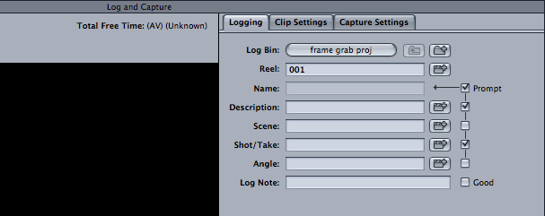

5. When taping, avoid problems with time code breaks. Each time you start recording, rewind a few frames so you are overlapping with the last shot. Time code is the numbering system on the tape that is used in editing. If you have time code breaks on a tape, you will have technical issues when editing. Also, Final Cut will not be able to make a complete and useful Edit Decision List (EDL). A complete EDL is very important when re-constructing a project at a later date.

6. If you have time code breaks on your tape, dub it to another DV tape. Give the new tape a different unique number and label it as a copy. For example, (AR009 Dub from AR003 3/4/09). In the process of dubbing, the time code will be replaced with new continuous time code. (You can use the original as a reference copy to protect the dub from wear.)

Time code may not be present with older analog videotapes that you may be digitizing for your project. Make sure when tapes are digitized, that time code is added in the process.

7. At the end of your final edit, render several different files at different quality. The rendered files (also called flattened files) are stored within your project folder. Render a higher quality file as your “edit master” file. Render lower quality files for making DVDs. Name these files beginning with the same prefix you used for the tapes; for example AR_final_edit.

8. Using the Media Manager module of Final Cut Pro, make a copy of your project to your archive hard drive. Check the “Delete unused media” box. The copy will be your complete project, without all the clips you digitized but did not use. Also, all the links are maintained. If you “drag and drop” your project, the links will be broken and you will be storing a bigger file than necessary. (Please note: all of the checked boxes in the example below may not be needed or recommended. See the Final Cut Pro manual.)

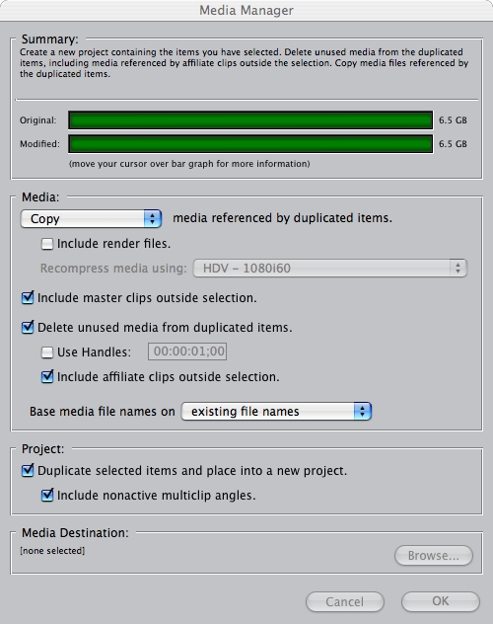

9. Also save the following into separate folders on your archive hard drive:
- Export the EDL under File > Export > EDL. Using the example above, you could name the folder and the file AR_EDL_export.
- Export the XML under File > Export > XML. This file contains a great deal of information (known as metadata) captured by the program and also the information input by you. The XML file is very important for trouble-shooting, for long term archiving, and for opening your project on different computer systems. Using the example, you could name the folder and the file AR_XML_export.
- Collect all of your electronic documents relating to the project and put them in one folder. Do the same for all the photographs, graphics and audio elements for the project, as well as any files created by digitizing analog video.
- Collect all of the files used for DVD authoring and save them into one folder.

10. Output your final edit to multiple DV tapes as backup, preferably DVCAM. As above, give each tape a unique number, and label the tape with its number, title, the record date, and indicate that it is an edit master. For example, AR025 Art of Resistance final edit recorded 4/12/09.

Store the copies in different geographic locations (such as with friends or in your office), and if possible, make a second archive hard drive and store it in a different location as well.

